SOUND SENSOR MODULE
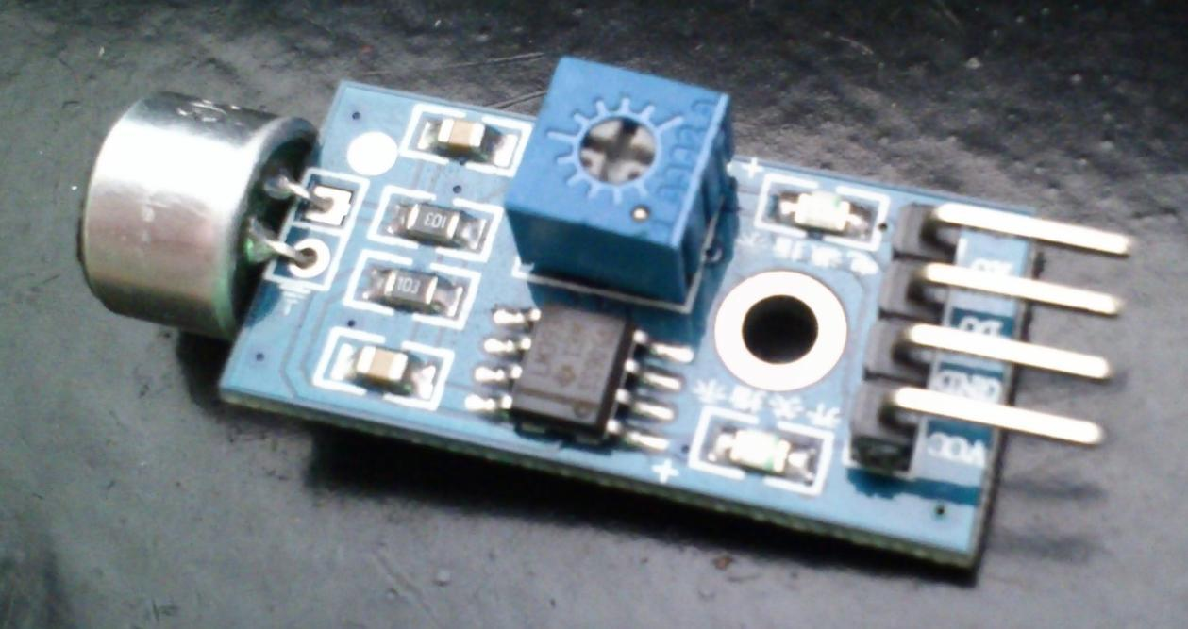

Description

The sound sensor module provides an easy way to detect sound and is generally used for detecting sound intensity. This module can be used for security, switch, and monitoring applications. Its accuracy can be easily adjusted for the convenience of usage.

It uses a microphone which supplies the input to an amplifier, peak detector and buffer. When the sensor detects a sound, it processes an output signal voltage which is sent to a microcontroller then performs necessary processing.

Specifications

- Operating voltage 3.3V-5V

- Output model: digital switch outputs (0 and 1, high or low level)

- With a mounting screw hole
- PCB size: 3.4cm * 1.6cm

Schematic Diagram
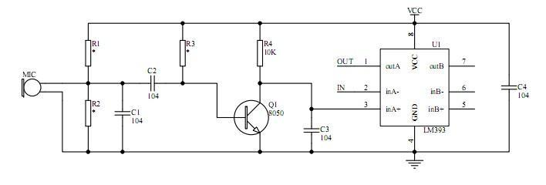

Pin Configuration
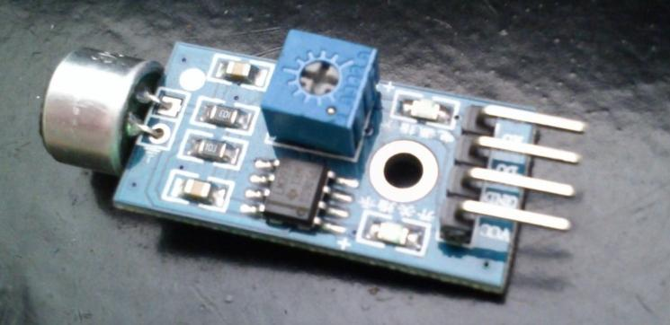

4
3
2
1

- VCC: 3.3V-5V DC

- GND: ground

- DO: digital output

- AO: analog output
Wiring Diagram
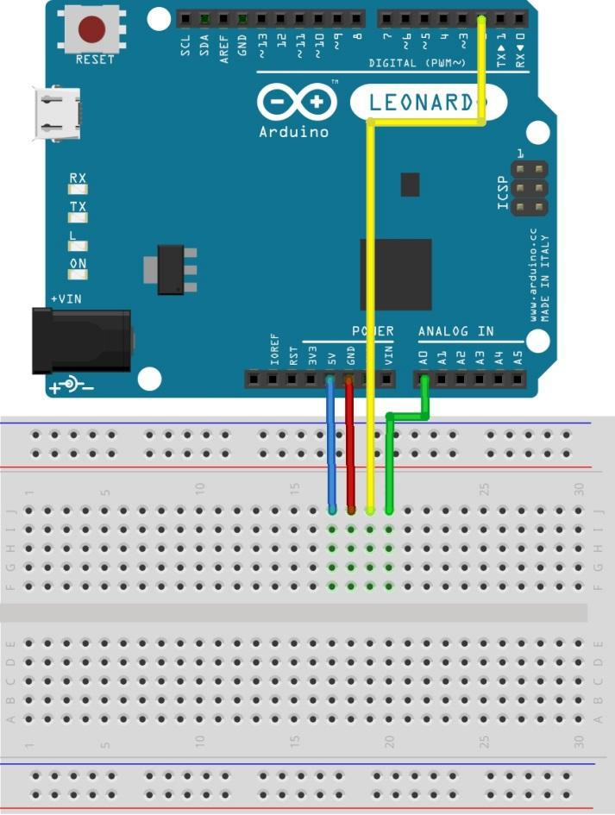

1 2 3 4

Sample Sketch

void setup(){
Serial.begin(9600);
pinMode(2, INPUT);
}

void loop()
{

if(digitalRead(2) == 0) Serial.println("no sound detected"); else Serial.println("sound detected"); delay(250);

}
How to test

The components to be used are:

  - Microcontroller (any compatible arduino)

  - Sound sensor module

  - 1 Pin M-M connectors

  - Breadboard

  - USB cable

- Connect the components based on the figure shown in the wiring diagram using a M-M pin connector. VCC pin is connected to the 3.3V or 5V power supply, GND pin is connected to the GND, DO pin is connected to a digital I/O pin and AO pin is connected to an analog pin. Pin number will be based on the actual program code.

- After hardware connection, insert the sample sketch into the Arduino IDE.

- Using a USB cable, connect the ports from the microcontroller to the computer.

- Upload the program.

- See the results in the serial monitor.

Testing Results

The figure below shows when the module was not subjected to sound.
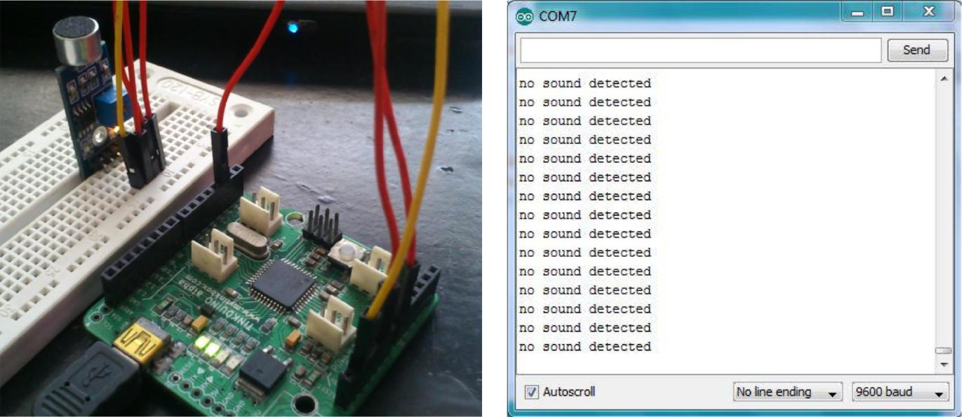

The figure below shows when the module was subjected to sound. Note that the red LED should also light up when sound is detected.
